Where in the World? Part B.

Now that you have some background information about the country you want to visit, I want you to plan at least a week-long vacation to that country. Create a Google Slideshow about the country/city you want to visit. Include as many pictures as you can while still answering the following questions:
- When will you be taking your trip? Why did you choose those dates?
- What season will it be in the country you have chosen to take a trip?
- Where will you be staying?
- How much money will you transfer to the particular currency? (Remember, when you transfer Canadian money for a different type, it may be more or less than you think because of the cost and transfer fees). You can Google currency rates.
  - You can use credit card, however some places around the world may only accept cash. For example, in Tokyo, most restaurants and small boutiques only accepted cash.
- Are there any customs you need to know before traveling to that country? For example, as a girl, sometimes you are expected to cover your hair.
- What types of things will you be doing on vacation? Will you be traveling around the country? Will you be doing any excursions? Will you be visiting any well-known world attractions?
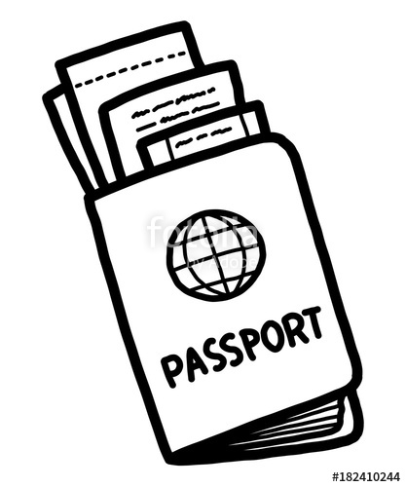
- What type of food will you be eating? Are there any big restaurants you want to try?

